Article title

AUTHOR'S NAME, SURNAME

Name of the University/Institute

Name of Faculty/Department

email

cIty, country

1. ABSTRACT

A brief overview of the research study should include its relevance, objectives, scientific novelty, practical significance, advantages, and results. The abstract must consist of one paragraph containing **80-120 words.** Abbreviations, references, and footnotes should not be included.

If the article is written in a language other than English, the title, the author's full name, the summary, and the keywords must also be provided in English.

1. Keywords: (At least 3 keywords)

Keywords should also be listed after the abstract.

1. ıNTRODUCTıON

The "Introduction" section outlines the goals and objectives of the research, its relevance, scientific innovation, practical significance, methods and methodology, and it’s positioning within the context of existing scientific literature.

In general, the introduction should consist of the following 4 parts:

1. Brief information related to the research is presented. The relevance and significance of the research are highlighted.
2. The need for research is indicated. Currently completed jobs and issues are displayed.
3. The research conducted to achieve the stated objectives is presented in detail.
4. The structure of the research is clearly outlined.
5. Research method (The names of the topics should be determined from the article)

The methods and materials employed to address the problem are outlined. Tables, block diagrams, graphs obtained as a result of conducted scientific experiments are shown. In this chapter, the efficiency of the research work is not disclosed, but the experiment and its result are disclosed.

1. CONCLUSION

The findings obtained as a result of the research are discussed. Accomplishments, advantages and work efficiency are noted.

1. References

References in the research paper are cited according to APA style. References are provided within the text at the end of the sentence in parentheses, including the authors (or authors') last name and the publication year. For example: (Gasimov, 2023). A period is placed after the reference. The references should be listed and should follow the following pattern:

1. Sari, DW, Khalifah, NA, & Suyanto, S. (2016). The spillover effects of foreign direct investment on the firms' productivity performances. Journal of Productivity Analysis, 46(2), 199–233.
2. Liu, Z. (2008). Foreign direct investment and technology spillovers: Theory and evidence. Journal of Development Economics, 85(1–2), 176–193.
3. Christie ohn Geankoplis. Transport Processes and Separation Process Principles. Fourth Edition, Prentice Hall, 2002
4. Sadychov F.S., Aydın C., Ahmedov A.İ. Appligation of Information – Communication Technologies in Science and education. II International Conference. “*Higher Twist Effects In Photon- Proton Collisions”, Bakı, 01-03 Noyabr, 2007, ss 384-391*

Additional

Format of chapters and texts

**The template** provides the formatting guidelines (font type, size, margin spacing, etc.) for each section (main heading, subheading, text, list, etc.) to structure the article appropriately. When working on the report template, the required format will be preserved. Changing this format **is not allowed**.

The text of the article should be between **1000 and 2000 words.**

Figures and tables

The picture, graph, block diagram, table, etc. given in the research should match the pattern below. Figures (graphs, flowcharts and tables) should be placed in the middle of the text.

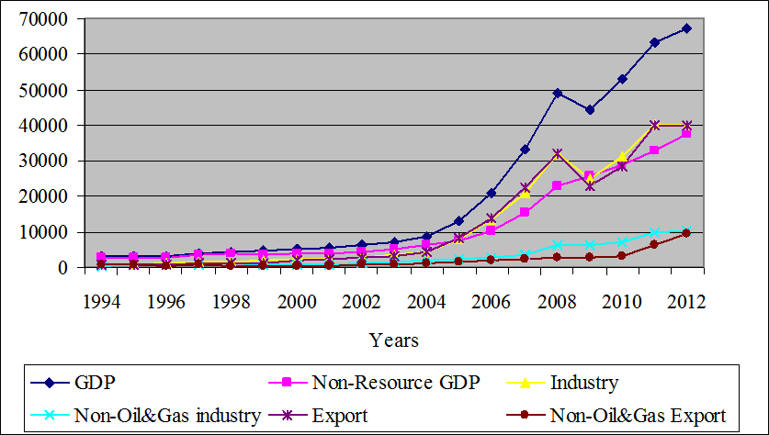

**Figure 1.** Comparative trends of Azerbaijan's GDP and GDP components, million US dollars

6 pt spacing should be left between image, image description and text. Each image should have a number and an explanation of the image in the text. When an image is taken from another source, a reference must be given.

***Table 1****. Changes in key macroeconomic indicators: 1995-2005*

|  |  |  |  |  |
| --- | --- | --- | --- | --- |
| **Years** | **GDP**  **(mln $)** | **GDP**  **Growth rate (%)** | **Inflation**  **(%)** | **Current account balance (% of GDP)** |
| 1995 | 3052.4 | -11.8 | 411.75 | -13.12 |
| 1996 | 3176.7 | 1.3 | 19.79 | -29.31 |
| 1997 | 3962.7 | 5.8 | 3.67 | - 23.11 |
| 1998 | 4446.4 | 10 | -0.77 | -30.69 |
| 1999 | 4581.2 | 7.4 | -8.52 | -13.09 |
| 2000 | 5272.6 | 11.1 | 1.80 | -3.19 |
| 2001 | 5707.6 | 9.9 | 1.54 | -0.91 |
| 2002 | 6236.0 | 10.6 | 2.77 | -12.32 |
| 2003 | 7275.7 | 11.2 | 2.23 | -27.77 |
| 2004 | 8680.5 | 10.2 | 6.70 | -29.83 |
| 2005 | 13245.4 | 26.4 | 9.67 | 1.26 |

***Source:*** *World bank, World Development Indicators 2006*

Equations

Each equation given in the text should be numbered. Equations should be written in the middle.

$α+β=γ$ (1)

**Important notes:**

**1. Articles will be accepted only in Azerbaijani and English languages.**

**2. Articles should be formatted in a single column.**

1. **Pages should not be divided by “page breaks” within the article.**
2. **Grouping of the “shapes” used for any figure within the article is required.**
3. **The title of the topic should be in font-12, the author's name and surname in font-10, the name of the University/Institute, the name of the Faculty/Department, e-mail, City, Country font-9, Abstract font-9, the keyword font-9, the text size font-11, spacing in between paragraphs font-3, and the references font-9.**
4. **One author can send maximum 3 articles.**
5. **Articles will not be accepted if they do not adhere to the provided instructions. \***