Article title
AUTHOR'S NAME, SURNAME
Name of the University/Institute
Name of Faculty/Department
email
cIty, country

- Summary
A brief overview of the research study. The relevance, purpose, scientific novelty, practical importance, advantages and results of the work should be included here. The abstract should be one paragraph and 200-250 words. Abbreviations, references and footnotes should not be used.
- Keywords: keyword-1, keyword-2, keyword-3
Keywords should also be listed after the summary in English.
- ıNTRODUCTıON
In the "Introduction" the goals and objectives of the research work, relevance, scientific novelty, practical importance, method and methodology, placement in the scientific literature, etc. is displayed. In general, the introduction should consist of the following 4 parts:
- The reader is given brief information related to the research. The relevance and importance of the research is indicated.
- The need for research is indicated. Currently completed jobs and issues are displayed.
- The research work carried out to achieve the set goal is disclosed.
- The reader is shown the structure (chapters) of the research paper.
- Research method
Methods and materials used to solve the problem are shown. Tables, block diagrams, graphs obtained as a result of conducted scientific experiments are shown. In this chapter, the efficiency of the research work is not disclosed, but the experiment and its result are disclosed.
- results and discussion
The results obtained as a result of the research are discussed. Accomplishments, advantages and work efficiency are noted.
- Reference list
References in the research paper are cited according to APA style. That is, at the end of the reference sentence, the last name of the author (or authors) and the date of publication are indicated in parentheses. For example: (Gasimov, 2023). A period is placed after the reference. The 5 most used references should be listed and should follow the following pattern:
- Sari, DW, Khalifah, NA, & Suyanto, S. (2016). The spillover effects of foreign direct investment on the firms' productivity performances. Journal of Productivity Analysis, 46(2), 199–233.
- Liu, Z. (2008). Foreign direct investment and technology spillovers: Theory and evidence. Journal of Development Economics, 85(1–2), 176–193.
- Negara, SD, & Adam, L. (2012). Foreign direct investment and firms' productivity level: Lesson learned from Indonesia. ASEAN Economic Bulletin, 29(2), 116–127.
- Kotil, E. (2020). The relationship between foreign direct investment and foreign trade in Turkey. Journal of the Faculty of Economics and Administrative Sciences of Süleyman Demirel University, 25(4), 417-426.
- Li, X. & Liu, X. (2005). Foreign direct investment and economic growth: an increasingly endogenous relationship. World Development, 33(3), 393-407

Additional
Format of chapters and texts
Formatting (font name, size, margin spacing, etc.) corresponding to each section (main heading, subheading, text, list, etc.) is given in the template to compose the article. When working on the report template, the required format will be preserved. Changing this format is not allowed.
The text of the article should be between 2000 and 8000 words.
Figures and tables
The picture, graph, block diagram, table, etc. given in the research should match the pattern below. Figures (graphs, flowcharts and tables) should be placed in the middle of the text.
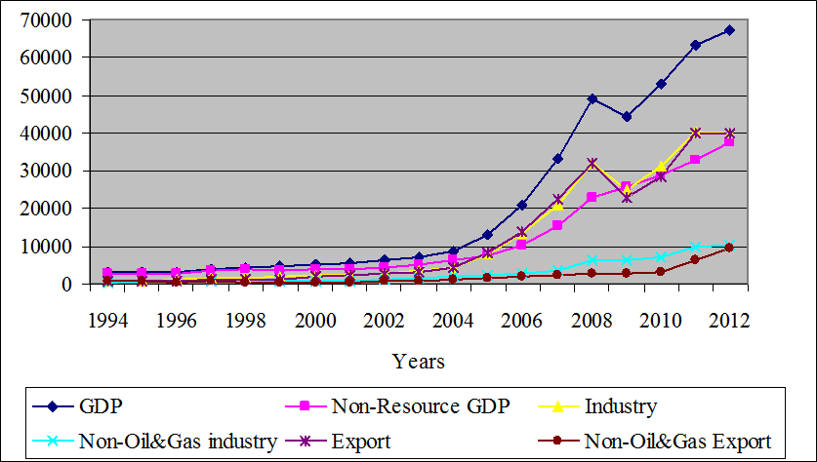
Figure 1. Comparative trends of Azerbaijan's GDP and GDP components, million US dollars
6 pt spacing should be left between image, image description and text. Each image should have a number and an explanation of the image in the text. When an image is taken from another source, a reference must be given.
Table 1. Changes in key macroeconomic indicators: 1995-2005

Years | GDP  (mln $) | GDP  Growth rate (%) | Inflation  (%) | Current account balance (% of GDP)
1995 | 3052.4 | -11.8 | 411.75 | -13.12
1996 | 3176.7 | 1.3 | 19.79 | -29.31
1997 | 3962.7 | 5.8 | 3.67 | - 23.11
1998 | 4446.4 | 10 | -0.77 | -30.69
1999 | 4581.2 | 7.4 | -8.52 | -13.09
2000 | 5272.6 | 11.1 | 1.80 | -3.19
2001 | 5707.6 | 9.9 | 1.54 | -0.91
2002 | 6236.0 | 10.6 | 2.77 | -12.32
2003 | 7275.7 | 11.2 | 2.23 | -27.77
2004 | 8680.5 | 10.2 | 6.70 | -29.83
2005 | 13245.4 | 26.4 | 9.67 | 1.26
Source: World bank, World Development Indicators 2006
Equations
Each equation given in the text should be numbered. Equations should be written in the middle.
$α+β=γ$ (1)

